Javascript string Methods
CharAt() - method returns the character at a specified index (position) in a string.
Index must be starts from 0.
ex-
<!DOCTYPE html>
<html>
<head>
<title></title>
</head>
<body>
<script type="text/javascript">
let t = "Rishabh";
document.write(t.charAt(1));
</script>
</body>
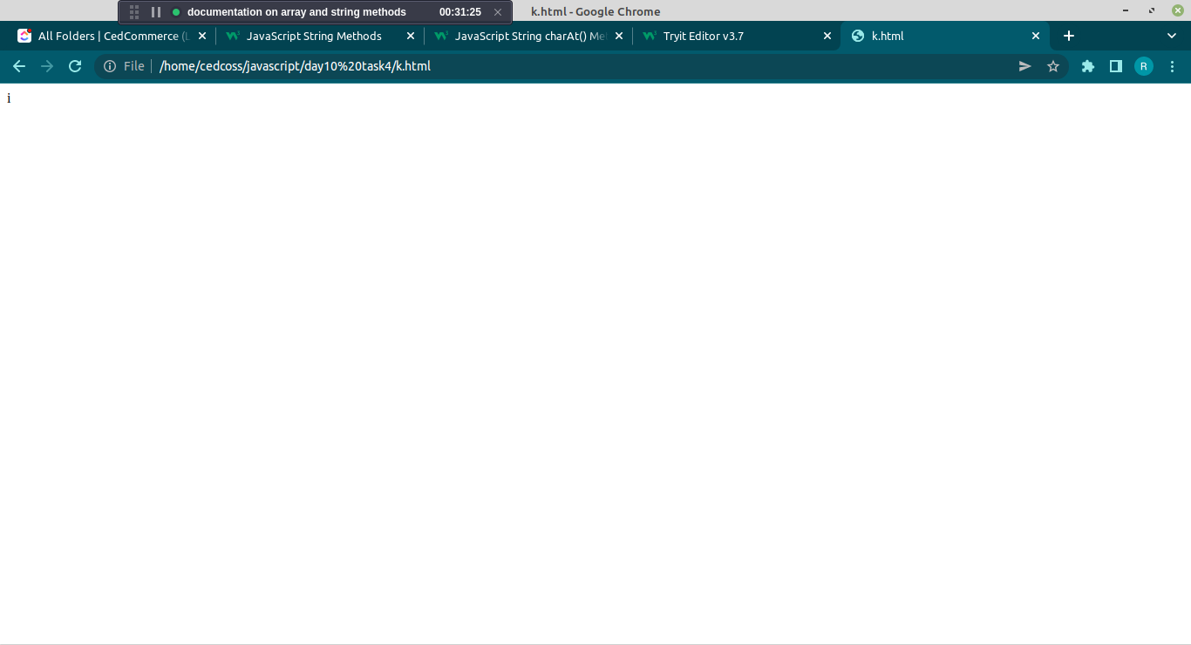
</html>

concat() -The concat() method joins two or more strings.
The concat() method does not change the existing strings.
Ex-
<!DOCTYPE html>
<html>
<head>
<title></title>
</head>
<body>
<script type="text/javascript">
let t = "Rishabh";
let s = "Singh";
document.write(t.concat(s));
</script>
</body>
</html>
Output – Rishabh Singh
Includes() - The includes() method returns true if a string contains a specified string.
Ex-
<!DOCTYPE html>
<html>
<head>
<title></title>
</head>
<body>
<script type="text/javascript">
let t = "Hello World, welcome to the universe.";
let s = t.includes("welcome");
document.write(s);
</script>
</body>
</html>
Output – true
indexOf- returns the position of the first occurrence of a value in a string:
Ex
<script type="text/javascript">
let t = "Hello World, welcome to the universe.";
let s = t.indexOf("o");
document.write(s);
</script> Output – 2
length- (property)- It return the length of string.
Ex-
<script>
let text = "this is mine";
let length = text.length;

document.getElementById("demo").innerHTML = length;
</script> Output – 12

replace() - method returns a new string with the value(s) replaced.
Ex-
<!DOCTYPE html>
<html>
<body>
<script>
let text = "I love John";
document.write(text.replace("love", "hate"));
</script>
</body>
</html> Output - I hate John

slice() - It extract the part of string from the giver string.
Split() - method splits a string into an array of substrings. method returns the new array.
Ex-
<!DOCTYPE html>
<html>
<head>
<title></title>
</head>
<body>
<script type="text/javascript">
let t = "This is my first Vehicle";
let s = t.slice(0,5);
document.write("This is result of slice -"+s+"<br>");
let z = t.split(" ");
document.write("This is result of split -"+z);
</script>
</body>
</html>

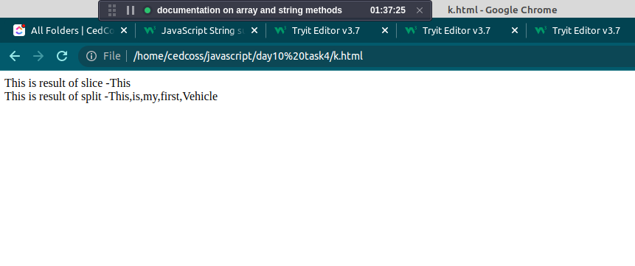

substr()- The str.substr() function returns the specified number of characters from the specified index from the given string.
substring() - This method get the characters from a string, between two specified indices, and returns the new string.
Ex-
<!DOCTYPE html>
<html>
<head>
<title></title>
</head>
<body>
<script type="text/javascript">
let text = "This is my first Vehicle";
let s = text.substr(1,3);
document.write("This is result of substr -"+s+"<br>");
let z = text.substring(1,3);
document.write("This is result of substring -"+z);
</script>
</body>
</html>
Output -

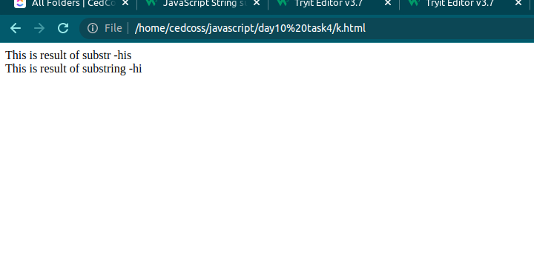
Methods of Array in Javascript

concat() - method concatenates (joins) two or more arrays.
This method returns a new array, containing the joined arrays.
Ex
<!DOCTYPE html>
<html>
<head>
<title></title>
</head>
<body>
<script type="text/javascript">
var fruits = ["Mango", "Apple"];
var a = ["pineaple"];
var b = ["guava"];
document.write(fruits.concat(a,b));
</script>
</body>
</html>
Output - Mango,Apple,pineaple,guava

filter() - method creates a new array filled with elements that pass a test provided by a function.
Ex-
<!DOCTYPE html>
<html>
<body>

<p id="demo"></p>

<script>
const ages = [32, 33, 16, 40];

document.getElementById("demo").innerHTML = ages.filter(checkAdult);

function checkAdult(age) {
return age >= 18;
}
</script>

</body> Output - 32,33,40
</html>

find() - returns the value of the first element in an array that passes a test (provided by a function).
Ex-
<html>
<body>

<p id="demo"></p>

<script>
const ages = [32, 33, 16, 40];

document.getElementById("demo").innerHTML = ages.find(checkAdult);

function checkAdult(age) {
return age >= 18;
}
</script>

</body> Output - 32
</html>

indexOf() - method returns the first index (position) of a specified value.
Ex -
<script>
const fruits = ["Banana", "Orange", "Apple", "Mango"];
let index = fruits.indexOf("Apple");

document.getElementById("demo").innerHTML = index;
</script>

map() - creates a new array from calling a function for every array element.
map() calls a function once for each element in an array.
map() does not execute the function for empty elements.

map() does not change the original array.
Ex-
<!DOCTYPE html>
<html>
<body>
<p id="demo"></p>
<script>
const numbers = [65, 44, 12, 4];
const newArr = numbers.map(myFunction);
document.getElementById("demo").innerHTML = newArr;
function myFunction(num) {
return num * 10;
}
</script>
</body>
</html>
Output - 650,440,120,40
reduce() - method executes a reducer function for array element.
Ex-
<!DOCTYPE html>
<html>
<body>

<h2>JavaScript Arrays</h2>

<p>Subtract the numbers in the array, starting from the left:</p>

<p id="demo"></p>

<script>
const numbers = [175, 50, 25];
document.getElementById("demo").innerHTML = numbers.reduce(myFunc);

function myFunc(total, num) {
return total - num;
}
</script>

</body>
</html>

